**Slaughterhouse – Schedule of fees**

1. Nindot og maka set ang user sa date ani nga fee.

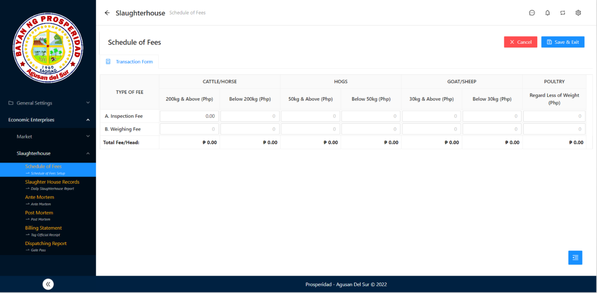

1. When clicking the input box the Saved Data Dialog will show ug mo click ka sa mga value adto dle mu total fee siya dle mo automatic.

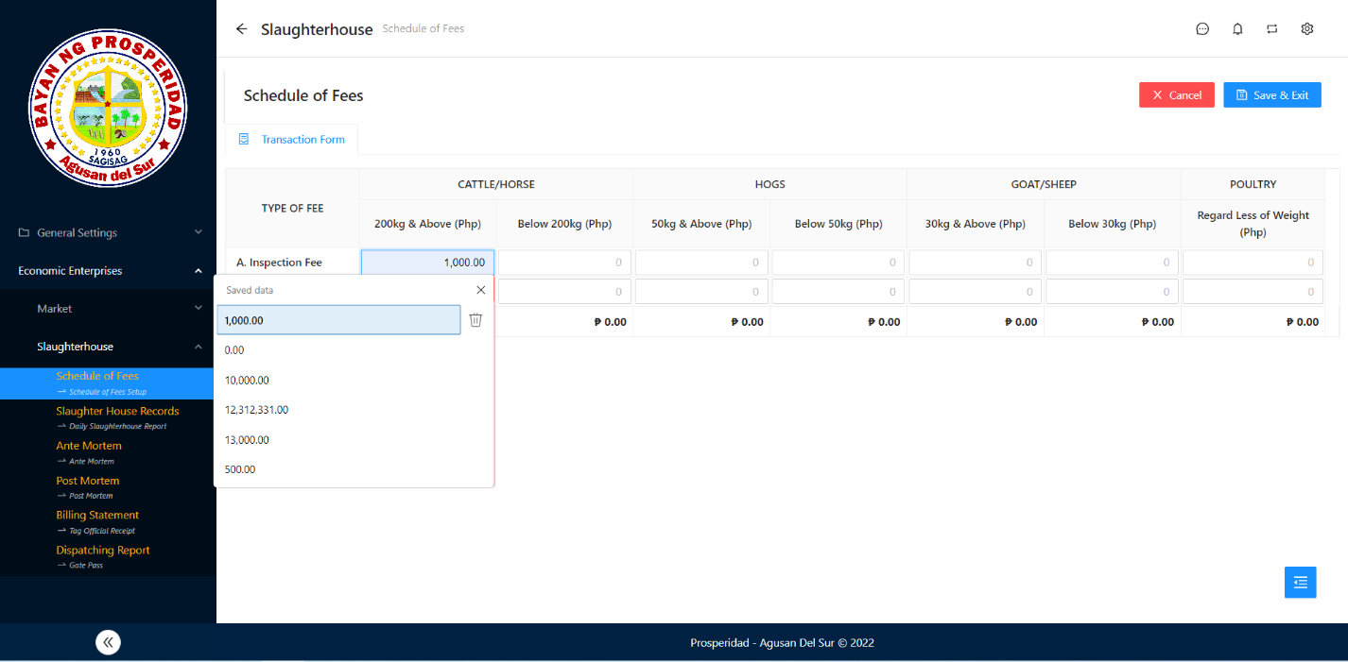

Click value

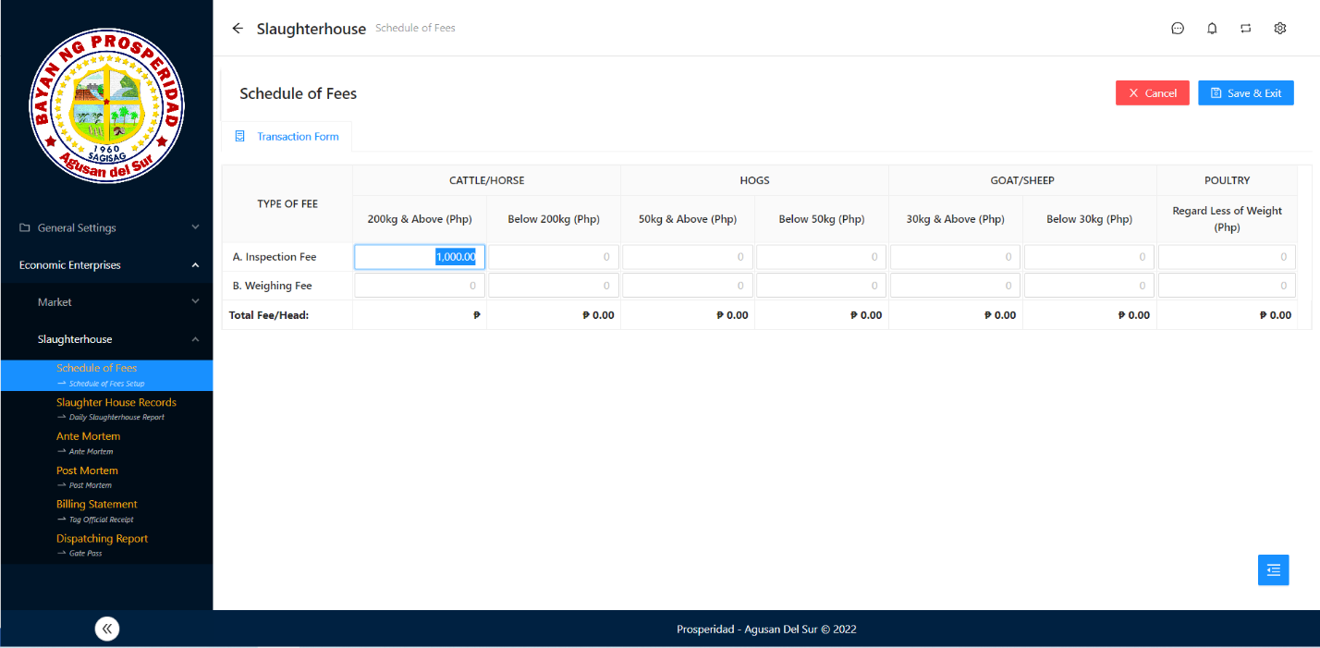

Result

1. Save & Exit Button Not Functional, Dile ka save.

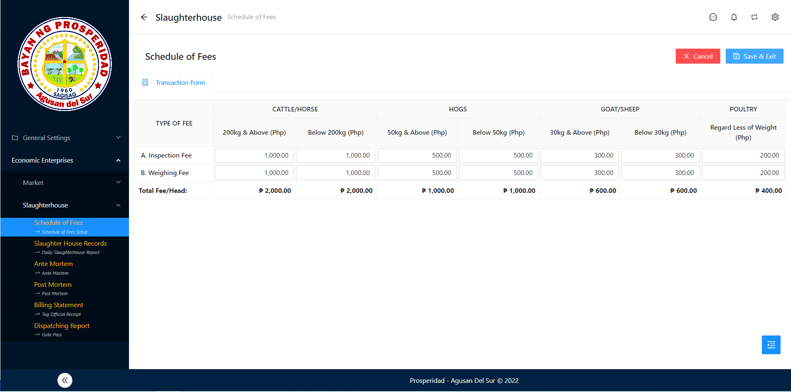

Not Functional

1. View nga function Schedule of fees Information asa gikuha?

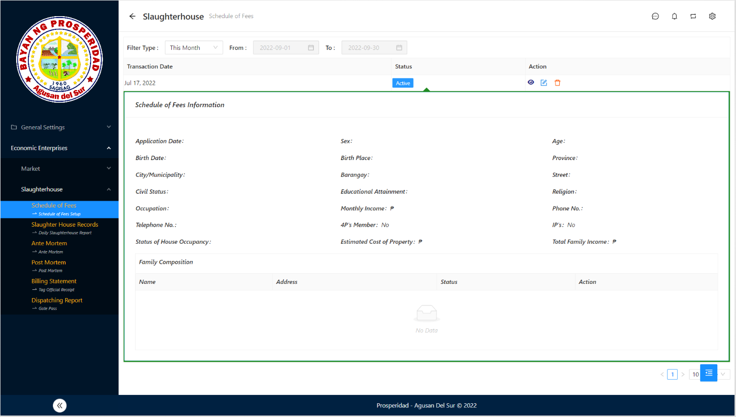

Asa gikuha?

**Slaughterhouse – Slaughter House Record**

1. Maka add siya bisan wala gi inspect then ang status kay draft.

1st Step

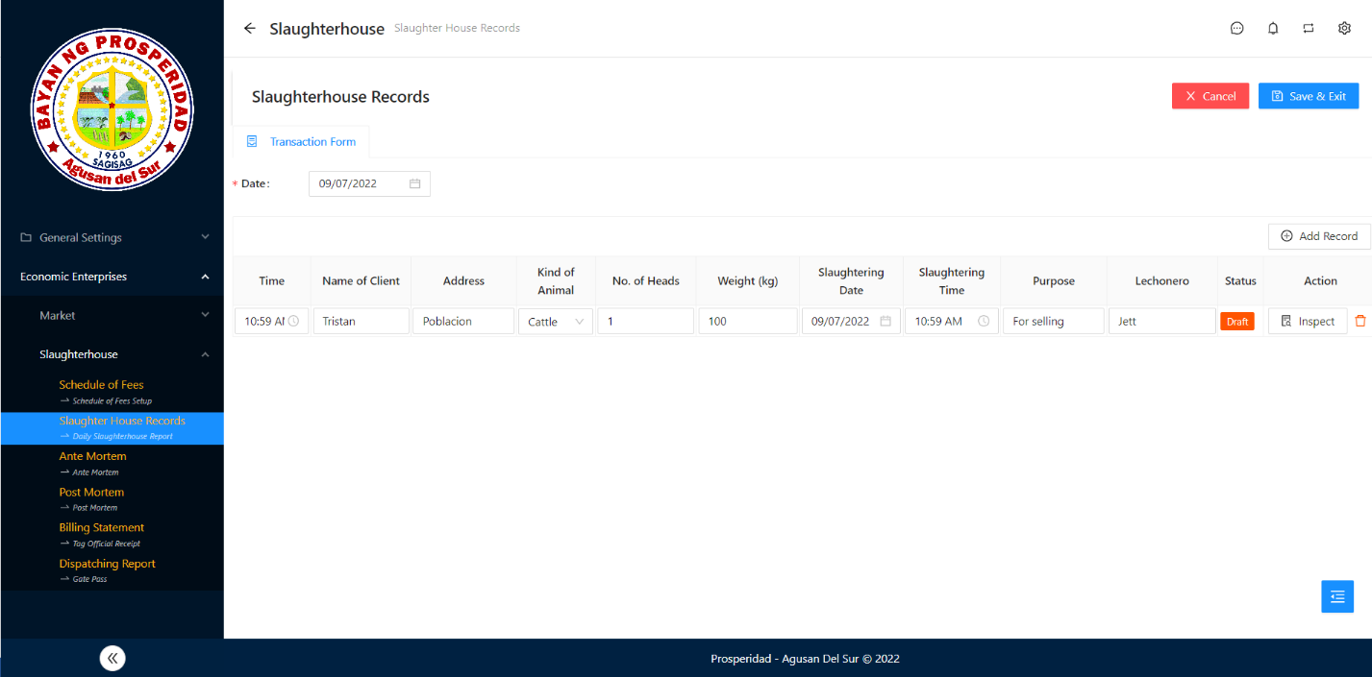

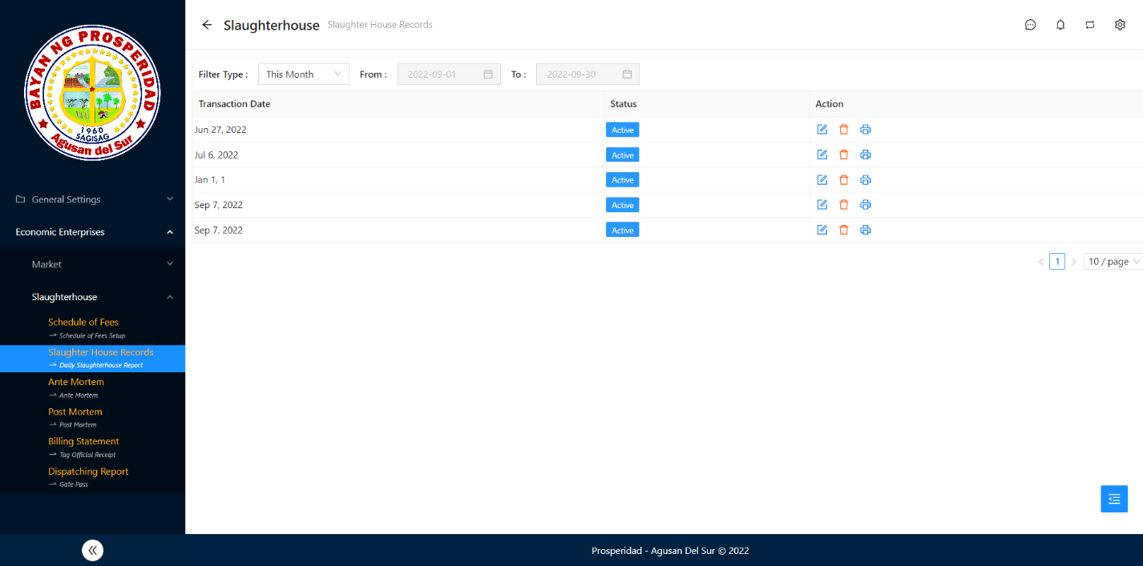

2nd Step

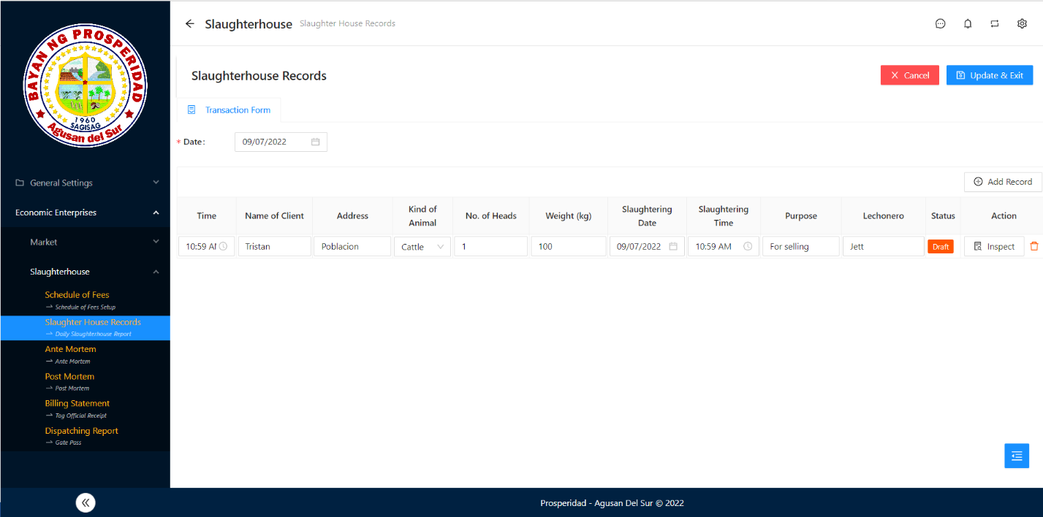

Result

**Slaughterhouse – Ante Mortem**

1. Species should change to Species Gender.

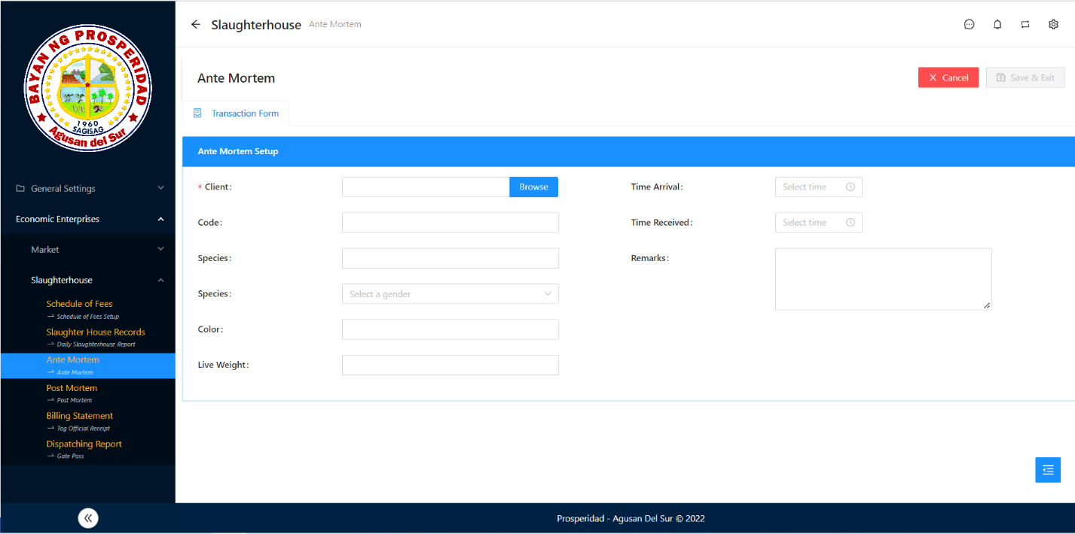

Change this

1. 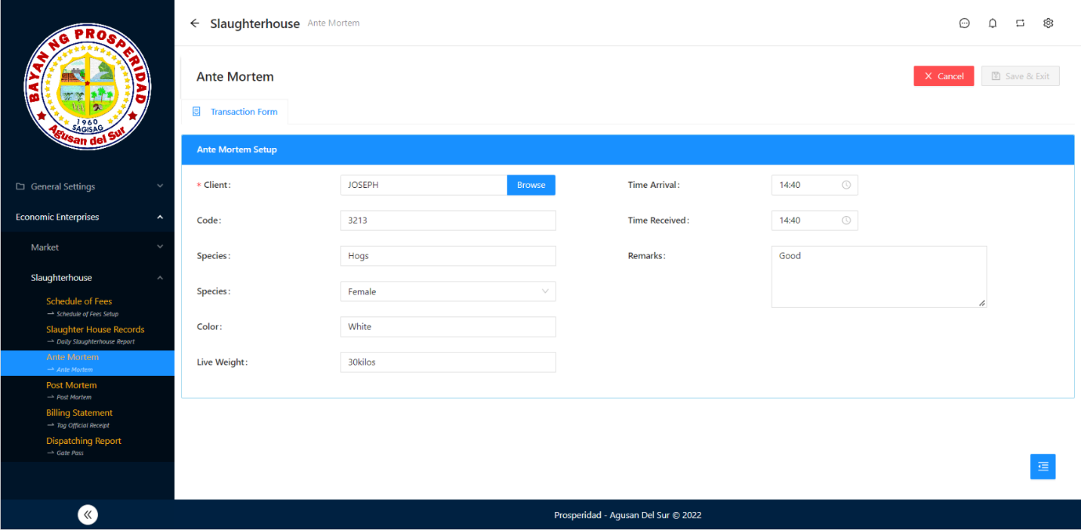Save & Exit Button Not Functional.

Not Functional

1. List should have the Client name, Code, Species, Species Gender, Color, Live Weight, Time Arrival, Time Received, and Remarks.

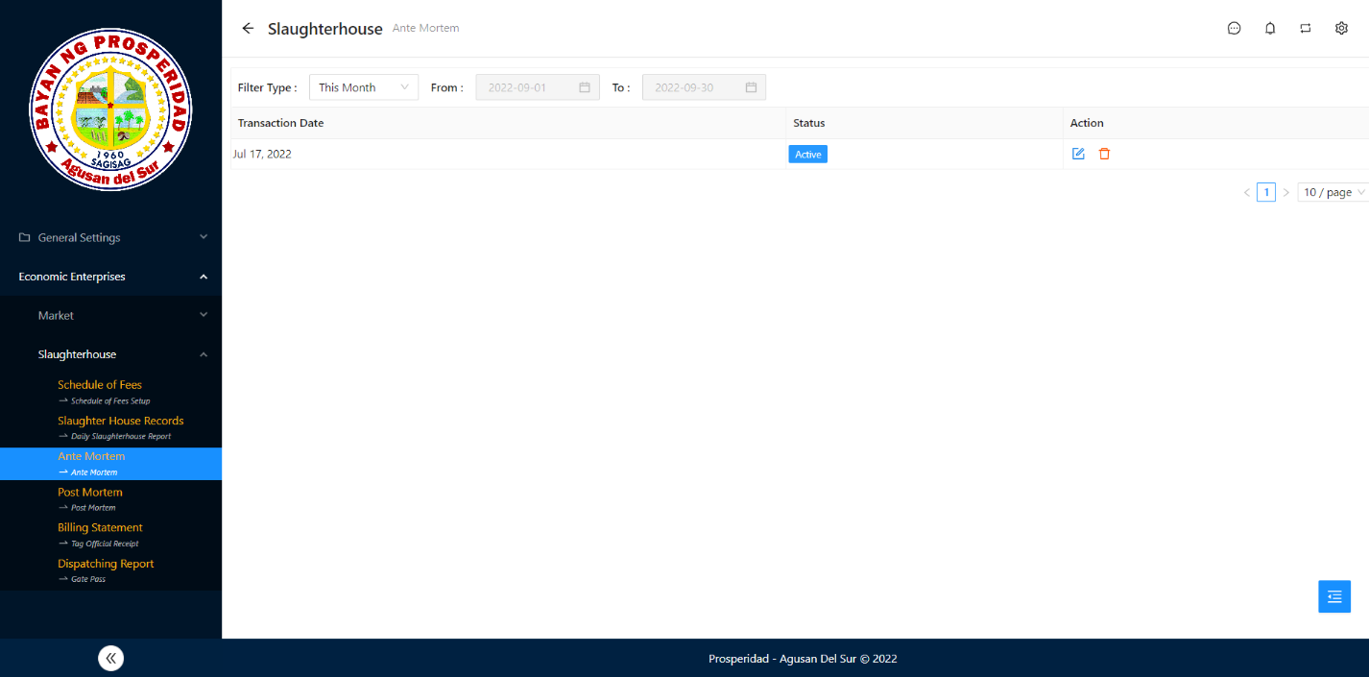

Add Column

**Slaughterhouse – Post Mortem**

1. Save & Exit Button Not Functional.

Not Functional

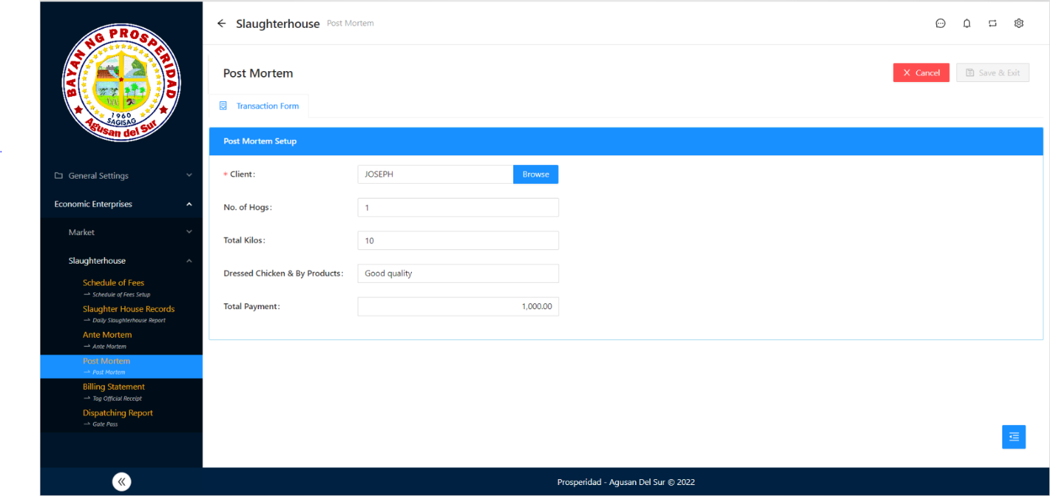

1. List should have the Client name, No. of Hogs, Total Kilos, Total Payment.

Add Column

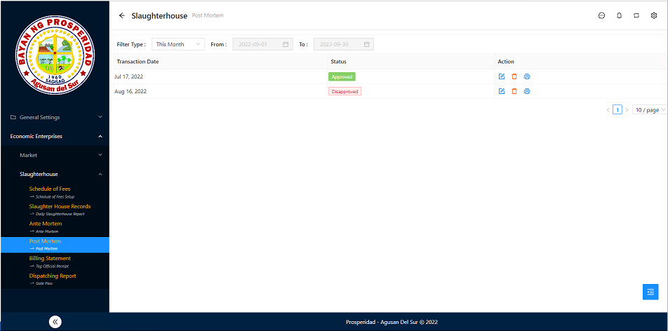

**Slaughterhouse – Billing Statement**

1. When clicking the input box Amount the Saved Data Dialog will show ug mo click ka sa mga value adto dle mu total amount siya dle mo automatic.

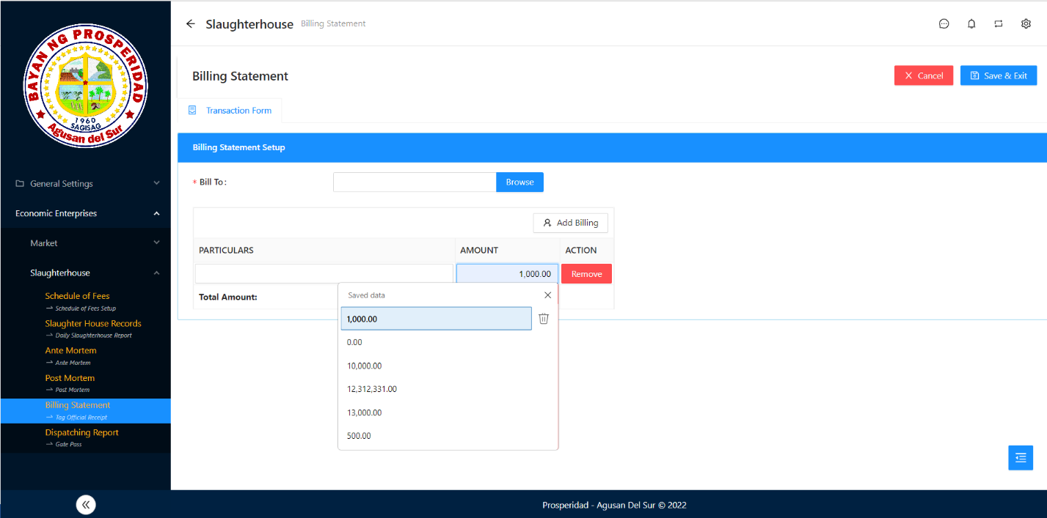

Click value

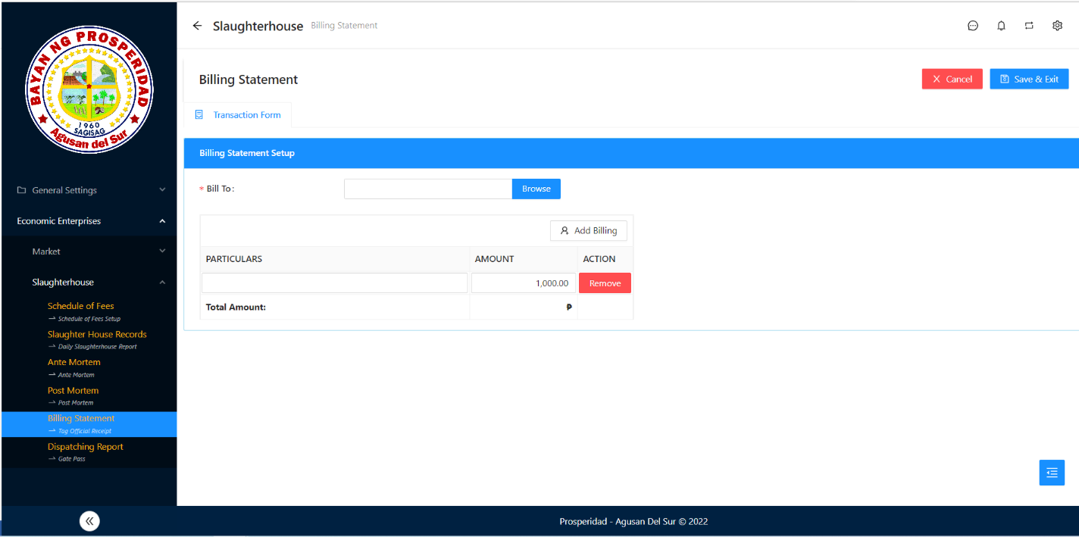

Result

1. Save & Exit Button Not Functional, Need to adjust the Add billing form.

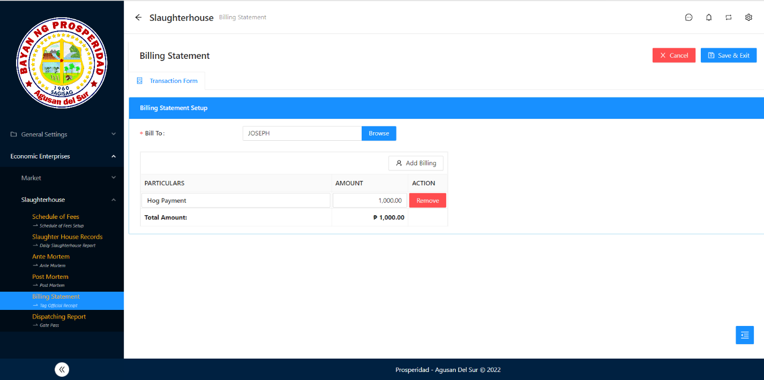

Not Functional

Need Adjust

**Slaughterhouse – Dispatching Report**

1. Maka add siya bisan wala gi inspect then ang status kay draft.

1st Step

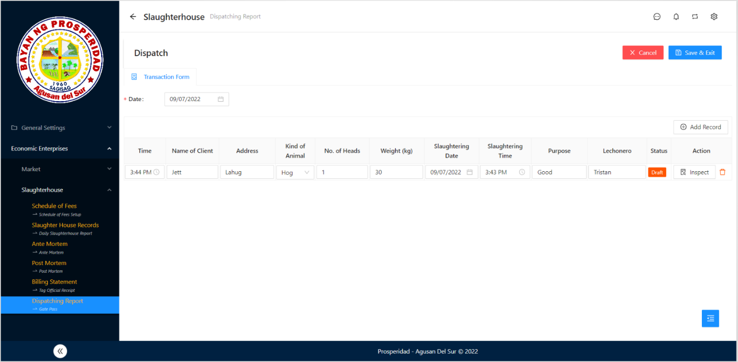

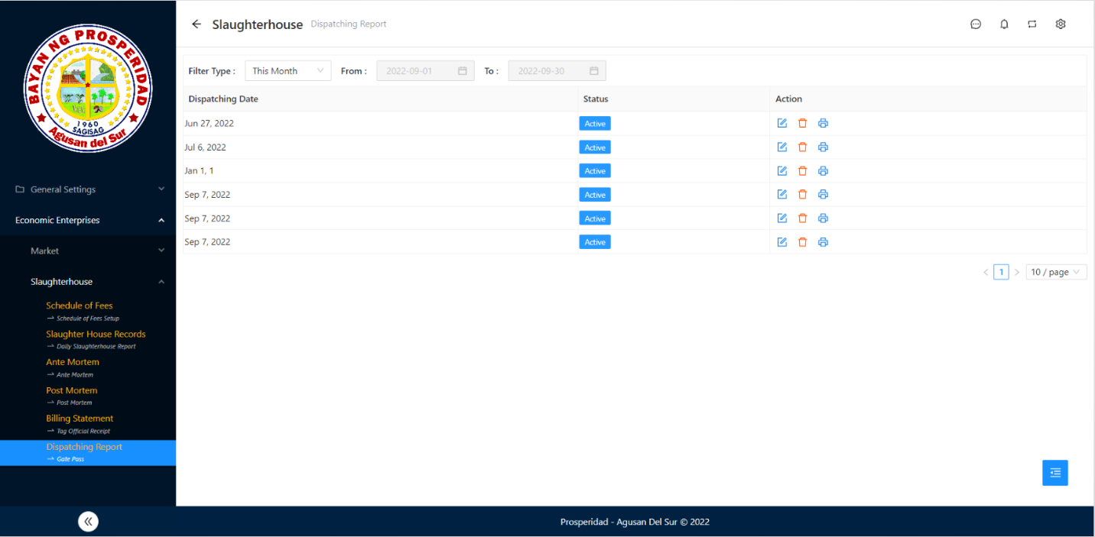

2nd Step

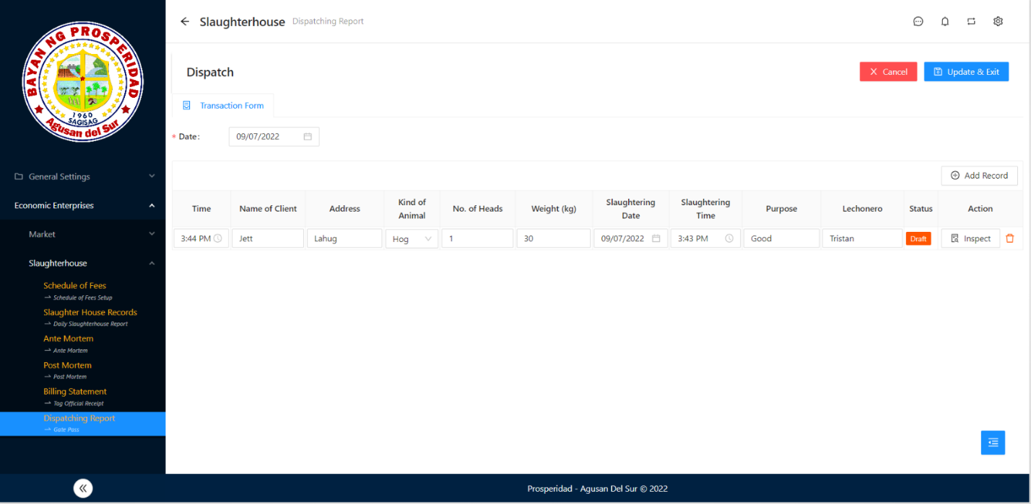

Result